WAM Client Installation Procedure

Blake Arellano – Last Updated 2/19/20

1. Install prerequisites:
   1. Install Anaconda (Python 2.7 version): <https://www.anaconda.com/distribution/>
      1. Make sure to check the option to add Anaconda to the system path!
   2. Once installed run Anaconda Prompt (Anaconda2) from the start menu
      1. This should open up a window similar to command line (cmd)
   3. Run the following commands to install needed python packages:

conda install pip

pip install tabulate

pip install Pyro4

* + 1. If this fails, it is most likely due to a permissions issue. Change the permissions of the Anaconda2 folder (C:/ProgramData/Anaconda2) to full permissions for all users

1. Add the client script to Window’s PATH:
   1. Get the WAM distribution from either:
      1. Git: <https://github.com/blaykareyano/WAM>
      2. Server: \\Boul-backup-01\Data\AE\Other\Computational Machines\WAM
   2. Move the contents of the client folder to C:\ProgramData\WAM
   3. Add the directory that contains the wam.bat and wam.py files to the system PATH:
      1. Search “Environment” in the start menu and select “Edit the system environment variables”
      2. You should get a window like this, select Environment Variables:

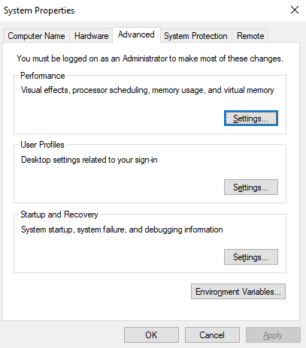

* + 1. Under system variables edit “Path”

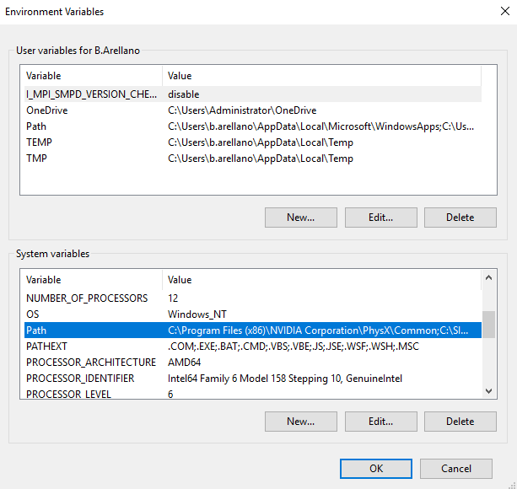

* + 1. Add the path to the wam.bat and wam.py files

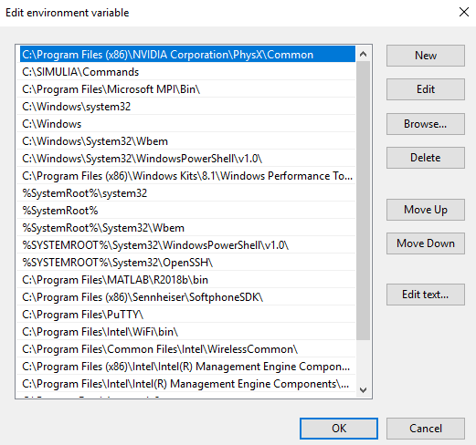

1. Edit the clientConf.json file
   1. Set the default email to be yours
   2. Make sure the naming server IP address is correct (currently cougar at 10.200.209.12)
2. Test that WAM is working by typing wam -ham into a command line.